**Curriculum Vitae**

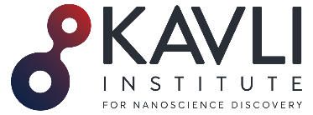

**Carol Vivien Robinson**

2. Organization and location

**Kavli Institute for Nanoscience Discovery**

Dorothy Crowfoot Hodgkin Building

Dorothy Hodgkin Road

Oxford

OX1 3QU, UK

[carol.robinson@chem.ox.ac.uk](mailto:carol.robinson@chem.ox.ac.uk)

<https://robinsonweb.chem.ox.ac.uk>

<https://kavlinano.ox.ac.uk>

<https://www.omass.com>

3. PROFESSIONAL PREPARATION

1980 – 1982 Doctor of Philosophy, University of Cambridge. Supervisor: Prof. D. H. Williams FRS

1979 – 1980 Master of Science, University of Wales. Supervisor: Prof. J. H. Beynon FRS

1976 – 1979 Graduate of the Royal Society of Chemistry, Medway College of Technology, Kent

1972 – 1976 ONC and HNC in Chemistry, Canterbury College of Technology, Kent

5. PRODUCTS

CURRENT GRANTS

2023 – 2028 ERC Advanced Grant €2,000,000. IMPLEMENT

2024 – 2028 Bipolar Disorder (BD2) £3,400,000.

Voltage-gated ion channels in Bipolar Disorder (Co-PI)

2021 – 2026 Medical Research Council £1,758,852

Developing MS to understand molecular mechanisms of antibacterial and antiviral drugs

2021 – 2026 Wellcome Trust Investigator Award £2,188,450

Targeting membrane proteins in native environments

2020 - present Kavli Foundation $10 M

Establish The Kavli Institute for Nanoscience Discovery (KIND)

2025 – 2027 Kavli Foundation $ 250,000

Research Ethics and Policy

1. Identifying Information

**Carol V. Robinson DBE FRS FMedSci FRSC**

Director, Kavli Institute for Nanoscience Discovery/Dr. Lee's Professor of Chemistry, University of Oxford

**Orcid ID:** 0000-0001-7829-5505

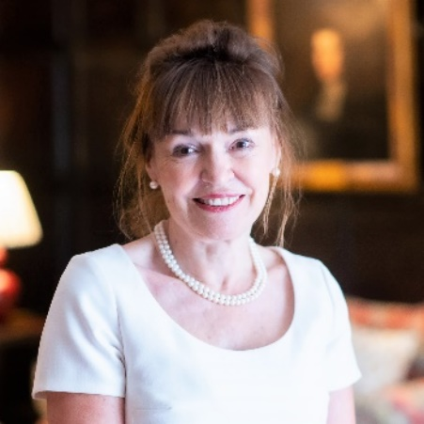

4. APPOINTMENTS AND POSITIONS

2021 Founder Director, Kavli Institute of Nanoscience Discovery

2016 Founder Director, OMass Therapeutics, Oxford

2009 Professorial Fellow, Exeter College, University of Oxford

2009 Dr Lee's Professor of Physical and Theoretical Chemistry, University of Oxford

2006 – 2016 Royal Society Research Professorship

2003 – 2009 Senior Research Fellow, Churchill College,

University of Cambridge

2001 – 2009 Professor of Mass Spectrometry, Department of

Chemistry, University of Cambridge

1999 – 2001 Titular Professor, University of Oxford

1998 – 2001 Research Fellow, Wolfson College, University of Oxford

1995 – 2001 Royal Society University Research Fellow, Oxford

1991 – 1995 Postdoctoral Research Fellow, University of Oxford

Supervisor: Prof. C. M. Dobson FRS

1991 – 1991 Postgraduate Diploma in Information Technology,

University of Keele

1983 – 1991 Career break to raise a family

1982 – 1983 MRC Training Fellowship, University of Bristol

1972 – 1979 Laboratory Technician, Pfizer, Sandwich, Kent

Technologies and techniques

During her early research, Carol developed and applied mass spectrometry to show how protein folding could be monitored in the presence of molecular chaperones. This research prompted her to find new ways to preserve mega Dalton complexes in the gas phase and led her to uncover the heterogeneity and dynamics of numerous multi-protein complexes.

In recent work, she has demonstrated the numerous roles played by lipids in regulating the structure and function of membrane protein assemblies.

Her current interest is in uncovering the synergy of lipid and drug binding. Informed by this research, she is exploring new ways to characterise receptor-signalling complexes.

Inventions, patent applications and licenses

Carol is a co-inventor on ten patents that are primarily focussed on the mass spectrometry of membrane proteins with various enabling features such as bespoke detergents, novel ionization methods, and new instrumentation. Six patents have been licensed.

###### Selected examples:

###### Detection of membrane protein-therapeutic agent complexes by mass spectrometry

**Patent number:** 9536718

**Inventors:** Carol V. Robinson, Sheila Wang, Nelson P. Barrera.

Filed: 2012

Granted: 2017.

###### Dendritic detergents for the analysis of proteins by mass spectrometry

**Publication number:**20210188902

**Inventors:**Carol V. Robinson, Idlir Liko, Hsin-Yung Yen, Kevin Pagel, Rainer Haag, Svenja Christina Ehrmann, Leonhard Hagen Urner.

Filed: 2021.

###### Detection of membrane proteins by mass spectrometry

**Publication number:** 20210325402

Inventors: Dror S. Chorev, Carol V. Robinson.

Filed: October 21, 2021

New business creation

As scientific co-founder of OMass Therapeutics, Carol helped raise Series B investment (US$110 million) from a syndicate of well-established investors, including Google Ventures, Syncona, Sanofi, and Northpond.

Using mass spectrometry, OMass are identifying and progressing new medicines to treat patients with rare

conditions and diseases that don't respond to treatments already on the market.

The company, whose defining technology is mass spectrometry, has now established more than 50 jobs and initiated on a brown-field site on the outskirts of Oxford.

[On founding OMass](https://eship.ox.ac.uk/professor-dame-carol-robinson-co-founder-of-omass/) and recent

[Discovery of a new potential therapy for IBD](https://www.fiercebiotech.com/biotech/roches-genentech-pens-420m-deal-omass-preclinical-ibd-program#:~:text=Roche's%20Genentech%20pens%20%24420M%20deal%20for%20Omass'%20preclinical%20IBD%20program)

6. SYNERGISTIC ACTIVITIES

Outreach, women in STEM and diversity

Carol has had an unorthodox career path, which began to take shape when she completed her graduate education while working full-time in industry. She then completed her PhD from the University of Cambridge in two years. Following an eight-year career break to raise her three children, she returned to research at Oxford.

In 2001, she became the first female Professor of Chemistry at the University of Cambridge, returning to Oxford in 2009 upon election to the Dr. Lee's Chair of Physical and Theoretical Chemistry.

Based on her extensive and varied experience throughout this journey, she regularly presents at Women in Science events and mentors many scientists. Her research group is consistently diverse, and ~30 of her researchers have gone on to establish independent academic groups worldwide.

Carol is also a member of the Advisory Board of the Royal National Children's Springboard with a mission to widen access to the best schools for young people facing the greatest barriers to development.

Advocacy and Leadership

As president of the Royal Society of Chemistry, Carol focussed on the roles of technicians and support staff in teaching and research laboratories. As President Elect of the Society, and as a former technician herself, Carol was keen to begin launching the Technician's Charter. This charter was designed to increase Visibility, Recognition and Career Development of technical staff. She continued to promote this cause throughout her presidency, presenting the first awards to technical staff and delivering lectures to highlight the roles of technicians. Over 100 higher education institutions have now signed up to this scheme, with the charter displayed in entrance halls across the UK.

In 2020, Carol became the founding director of the Kavli Institute for Nanoscience Discovery in Oxford (KIND), an interdisciplinary science institute with a mission to bring together eight different departments across two divisions. To coincide with this opening, Carol applied for funding to initiate a Research Culture Program to give all researchers a voice in shaping the institute and to introduce a collaborative, supportive and non-competitive environment.

[On founding the Kavli Institute](https://kavlinano.ox.ac.uk/get-involved)

Today the institute is over-subscribed with many scientists from the eight departments competing for space. Moreover, the institutes ‘open-door’ policy means that it regularly hosts scientists from disadvantaged backgrounds and ethnic minorities, and it has recently secured significant research funding as well as grants for displaced scientists.

She recently secured further funding from the Kavli Foundation to appoint Research Fellows in Ethics and Policy to engage with researchers to identify and ameliorate ethical risks and to promote responsible research practice.